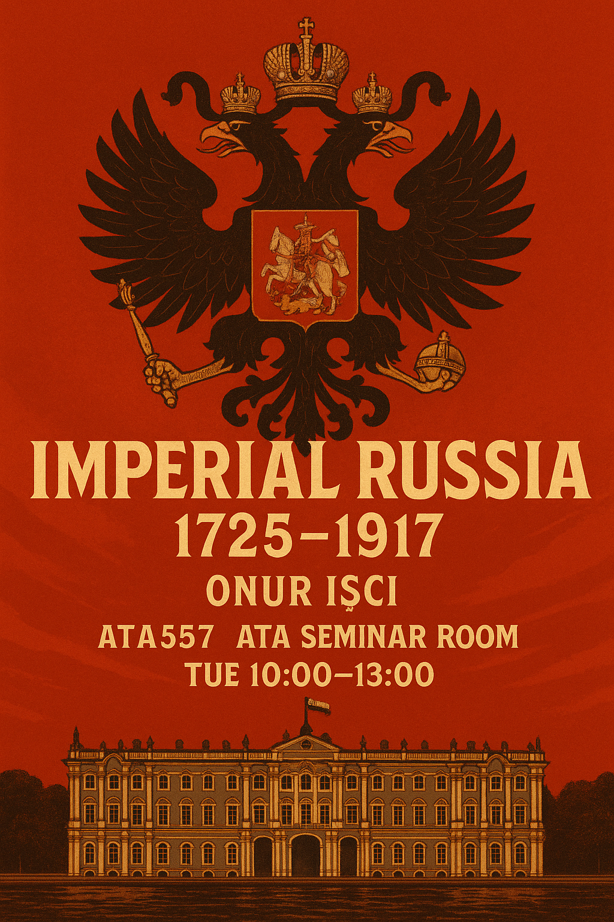

COURSE DESCRIPTION

This course is designed for graduate students as a comprehensive survey of imperial Russian history. It traces the evolution of Russian institutions and political order from Petrine reforms (early 18th century) all the way through revolutionary Russian politics under Lenin. The main purpose of my lectures will be to go beyond existing binarisms in historical scholarship (such as good and evil), and help students place Russia in a transnational context. We will examine Russia through many lenses – diplomatic, political, economic and cultural – but our main attention will be on (1) reasons behind and impact of revolutions; (2) the state and the people; (3) industrialization and the drive for development; (4) imperial and Soviet nationality policy; (5) great power politics and the emergence of regional conflicts.

OBJECTIVES & FORMAT

To the uninformed audience, Russia is often considered enigmatic. If you complete the reading assignments on time and engage in active discussion with your peers, you will have a better understanding of Russia’s past, which – you will realize – is not really that mysterious. By the end of the semester, students who attend classes regularly will demonstrate a working knowledge of the historical processess through which contemporary Russia came into being.

I have organized this class around around a series of lectures and discussions, which will introduce students to the peoples, places, events and issues that we will focus on in our readings. Russia’s relations with the West and its drive for modernization will occupy a large portion of our meetings and we will drive home this main theme through a straightforward chronology, which I tried to briefly summarize in the next section. The overall success of the class will depend to a significant degree on students’ willingness to engage in discussion; a full %30 of your grade is derived from your participation in discussion sessions.

SCOPE & READINGS

From a small principality in Moscow, the Tsardom of Russia grew 35,000 km² each year between Ivan the Terrible’s conquest of Kazan in 1552 and Peter the Great’s signing of the Treaty of Nystad in 1721. Throughout the tumultous 18th Century, the Romanov Empire continued to expand, and by the the time of the Spring of Nations in 1848, Russia was considered the strongest country in Europe. The Romanovs seemed impelled to expand by a rhythm all its own, containable only by the deployment of superior force, and usually by war. European powers have always found something decidedly eerie about the vastness and persistence of this country. Thwarted, Russia nursed its grievances and bided its time for revenge – against Great Britain throughout much of the 19th century, against Austria after the Crimean War, against Germany for the Congress of Berlin. The irony was that, after a certain point, expansionism no longer enhanced Russia’s power but brought about its decline.

Between 1848-1914, Russia was involved in over half a dozen wars (other than colonial wars) far more than any other major power. In each of these conflicts the financial and political costs to Russia far exceeded the possible gains. When the 304-year-old Romanov dynasty collapsed after two revolutions in 1917, it bequeathed the world’s largest multi-ethnic, multi-confessional society to their successors – the Bolsheviks. United in shared bitterness against the Soviet Union’s isolation from the new international order that emerged in Versailles in 1919, Lenin and his comrades were driven by a restless desire for development and to match Western power. This motive persisted through much of Soviet history. The Kremlin was equally determined to improve the human condition through communism, and reached out to the Third World in a global competition with the United States. But when the Soviet Union collapsed in 1991, it was an underdeveloped superpower and the suddenness of its fall came as a shock not only to the rest of the world but to its own citizens. In Alexei Yurchak’s words, it was as if “everything was forever until it was no more.”

To fully understand the twists and turns in the picture described above, we will read two main textbooks:
- Geoffrey Hosking’s Russia and the Russians: A History (Cambridge, MA: Belknap, 2011). This is a widely read popular source on Russian history and we will be using it for the period between 1725 through 1881.
- Onur İşçi & Onur Önol, Harp Yahut İhtilal: Rusya İmparatorluğu’nun Çöküşü, 1881-1917 (İstanbul: Kronik, 2019). This is a popular survey history of Russia all the way from the assasination of Alexander II in 1881 through the revolutionary turmoil in Russia in 1917.

ASSIGNMENTS

Participation (20%)
Students are expected to actively participate in all of my lectures and discussion sessions. Participation in discussions does not require knowledge of all the answers; thoughtful questions are equally valuable. Intellectually stimulating remarks and questions will potentially raise your participation grade, hence your overall grade for the semester. If you meaningfully contribute to our discussions —including by asking questions—in approximately half of our courses, this would be the equivalent of a “B.” Occasional participation or participation that does not demonstrate meaningful engagement with the readings is a “C.” By the end of the semester if you participated only in passing (i.e. once or twice) you will get a “D.” Silence is an “F.” The grade of “A” is reserved for students who regularly contribute in a particularly thoughtful way to discussions.

Response Papers (20%):
A response paper is essentially a short reflection (approximately 800-1000 Words) of your thoughts about the reading assignment’s main argument, format and research methodology etc. Rather than a summary of the text, you tell me whether the argument is convincing or not. You are required to submit 2 response papers throughout the semester (10 points each) on any given discussion session’s readings. You will also be leading a discussion with pointed questions on the corresponding week of your response papers.

Final Paper (60%)
This is to be a substantial research paper on a topic developed in consultation with me. Papers will be 3,000 words in length excluding footnotes and bibliography. You are also required to schedule a meeting with me to discuss the reading and research materials for your project. I can direct you to appropriate sources but given my teaching load this semester I will not be able to read early drafts and give you preliminary feedback. After the Spring Break, however, you will present paper proposals, on which I will provide you with comments and instructions. A proper presentation will include (1) a semi-developed research question; (2) some sort of main argument; (3) preliminary outline; and (4) a simple bibliography that includes secondary and – if possible – primary sources. The key here is to be bold and innovative rather than overzealously academic, which leads to nothing but boring papers.

WEEKLY SCHEDULE

Part I: Empire Ascendant, 1725–1881
Week 1 — Autocracy After Peter: Succession and Stability
- Reading: Isabel de Madariaga, “Russia in the Age of Catherine the Great” (Cambridge, 1981), Ch. 1
- Literature: A. Pushkin, The Bronze Horseman
- Themes: Post-Petrine statecraft, imperial vision, Petersburg as metaphor.

Week 2 — Catherine the Great and Enlightened Absolutism
- Reading: Richard Wortman, Scenarios of Power, vol. 1, Ch. 3 (“The Empress and the Enlightenment”)
- Literature: A. Pushkin, The Captain’s Daughter
- Themes: Autocracy and reform, imperial ideology, mythmaking.

Week 3 — The Age of Reaction: Nicholas I and Official Nationality
- Reading: Nicholas Riasanovsky, “Nationality and Official Ideology under Nicholas I,” Russian Review 19:1 (1960)
- Literature: N. Gogol, The Government Inspector
- Themes: Bureaucratic empire, censorship, the absurdities of power.

Week 4 — Crimean War and Reformist Impulses
- Reading: David Saunders, Russia in the Age of Reaction and Reform (Longman, 1992), Ch. 2
- Literature: L. Tolstoy, Sevastopol Sketches
- Themes: War and legitimacy, imperial weakness, calls for modernization.

Week 5 — Emancipation and the Great Reforms
- Reading: Terence Emmons, “Emancipation and the Great Reforms,” in The Cambridge History of Russia, vol. II
- Literature: I. Turgenev, Fathers and Sons
- Themes: Social transformation, liberalism vs. nihilism, generational conflict.

Week 6 — Industrialization and the Seeds of Change
- Reading: Theodore Von Laue, “The Industrialization of Russia,” Slavic Review 25:1 (1966)
- Literature: F. Dostoevsky, Notes from Underground
- Themes: Urbanization, social dislocation, alienation and modernity.

Part II: Crisis and Collapse, 1881–1917
(All historical readings from Onur Işci, Harp Yahut İhtilal: Rusya İmparatorluğu'nun Çöküşü)
Week 7 — Autocracy Under Siege: Alexander III and the Counter-Reform Era
- Literature: M. Saltykov-Shchedrin, The Golovlyov Family (selections)
- Themes: Reaction, repression, and the consolidation of state power.

Week 8 — Empire of Nations: Nationality, Russification, and Resistance
- Literature: G. Uspensky, The Peasant and the Intelligentsia (selections)
- Themes: National policies, imperial peripheries, colonial governance.

Week 9 — The Rise of Revolutionary Thought
- Literature: N. Chernyshevsky, What Is to Be Done? (selections)
- Themes: Populism, Marxism, and the intellectual roots of revolution.

Week 10 — 1905: Revolution and Reform
- Literature: L. Andreev, The Seven Who Were Hanged
- Themes: The first revolution, the Duma, and the limits of reform.

Week 11 — The Silver Age: Culture and Crisis
- Literature: A. Blok, The Twelve
- Themes: Modernism, mysticism, and the twilight of empire.

Week 12 — War and Imperial Overstretch, 1914–1916
- Literature: I. Bunin, The Village (selections)
- Themes: Total war, rural discontent, imperial fragility.

Week 13 — 1917: Collapse and Revolution
- Literature: A. Gorky, Untimely Thoughts (selections)
- Themes: State breakdown, dual power, revolutionary legitimacy.

Week 14 — After the Empire: Historiography and Memory
- Literature: Trotsky, History of the Russian Revolution, Introduction
- Themes: The meaning of imperial collapse and its legacies in Russian and global history.

